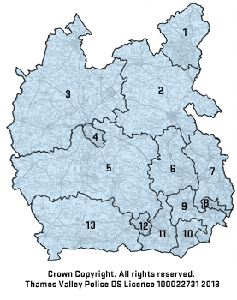
Thames Valley Police is divided into twelve Local Policing Areas (LPA); the following are police stations where newly recruited police officers can be stationed:
- Milton Keynes LPA – Milton Keynes
- Aylesbury Vale LPA – Aylesbury
- Cherwell and West Oxfordshire LPA – Banbury, Bicester, Witney
- Oxford LPA – Cowley
- South Oxfordshire and the Vale of the White Horse LPA – Abingdon, Didcot, Henley, Thame, Wantage
- Wycombe LPA – High Wycombe
- Chiltern and South Buckinghamshire LPA – Amersham
- Slough LPA – Slough
- Windsor and Maidenhead LPA – Maidenhead, Windsor
- Bracknell & Wokingham LPA – Bracknell, Loddon Valley
- Reading LPA – Reading
- West Berkshire LPA – Newbury

Please ensure you use the internet to calculate which towns and cities you could be posted to within 20 crow miles from your current address (or and address you are moving to).

