May 2022

Dear Applicant,

Appointment of Chief of Staff

Thank you for your interest in becoming my Chief of Staff.

Having been in post of just a year I have already implemented a number of changes and continue to drive forward with a busy programme of work. I have made a number of new appointments within my senior team and a new Chief of Staff completes this opportunity to make a real difference for all of the communities we serve. I am looking for someone with leadership and vision who can harness the abilities of the great team I already have in place and work with me to deliver my Police & Criminal Justice Plan.

In this role, you will work closely with me to ensure that the Police are focused on preventing crime and delivering justice for victims. You will be key to supporting my work, and that of my wider team, working with partners to improve the criminal justice system and constantly strive to make Thames Valley safer. Finally, we will work together to ensure that the Force gets the best equipment and resources to do their difficult job.

Within the Office you will ensure that our services are of the highest quality. Effective commissioning to ensure that victims of crime are supported and that we seek to prevent crime and drive down reoffending. You will support me in the effective scrutiny of the Police, where the focus is on those issues that matter to the public not just those that we can easily count.

Thames Valley is one of the largest police areas in the country and covers many diverse communities. I therefore encourage all applications from as wide a range of backgrounds as possible.

In summary I want you to focus on keeping the ship running effectively and efficiently whilst I focus on holding the Force to account and continually strive to reduce crime and keep people safe. I look forward to receiving your application, setting out the part you want to play in making Thames Valley even safer.

Yours sincerely,
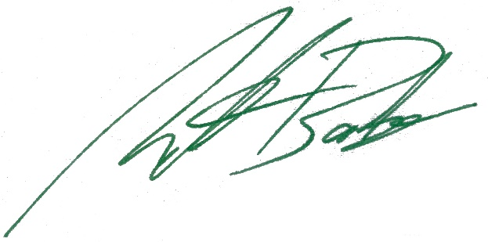
Matthew Barber
Police & Crime Commissioner

