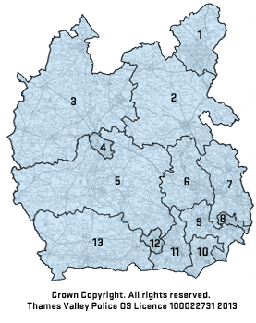
Thames Valley Police is divided into twelve Local Policing Areas (LPA); the following are police stations where newly recruited police officers can be stationed:
- Milton Keynes LPA – Milton Keynes
- Aylesbury Vale LPA – Aylesbury
- Cherwell and West Oxfordshire LPA – Banbury, Bicester, Witney
- Oxford LPA – Cowley
- South Oxfordshire and the Vale of the White Horse LPA – Abingdon, Didcot, Henley, Thame, Wantage
- Wycombe LPA – High Wycombe
- Chiltern and South Buckinghamshire LPA – Amersham
- Slough LPA – Slough
- Windsor and Maidenhead LPA – Maidenhead, Windsor
- & 11. Bracknell & Wokingham LPA – Bracknell, Wokingham
12. Reading LPA – Reading
- West Berkshire LPA – Newbury

Please ensure you use the internet to calculate which towns and cities you could be posted to within 20 crow miles from your current address (or an address you are moving to).

Initial postings are for a period of two years and there will be no opportunity to transfer to another LPA within this time. Once you have successfully completed your two year probation you may look at transferring to another area, specialising into a different department or considering your options around promotion.

